8.29.17
Meeting Notes

- We should not be calling owners with lab results if they have an outstanding balance unless there is a note in their invoice screen (making payments, etc.) If an owner asks to make payments to their account they must be approved by Shannon.
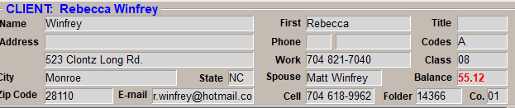
You can tell if they have a balance by looking at the client screen.

- How to note why someone owes money:
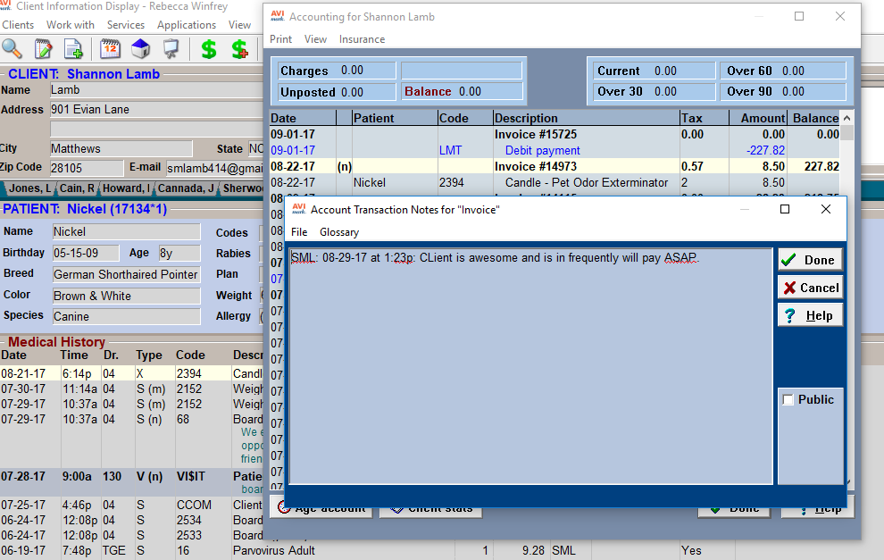
Make a note why the client is splitting payments. Make sure these are approved by Shannon.
Right click & select notes, the (n) will indicate that there is a note there.
Click here first.

- Make sure to enter a patients weight every time they come in, regardless if it’s for an appointment, tech visits, boarding, etc.
- Oral Canine Bordetella Vaccines – We should be using the oral Bordetella vaccines as our “go-to” but continue to booster puppies with injectable. Make sure to use the oral Bordetella syringes when drawing them up.
- Please enter all information into Avimark once a client fills out their initial registration form. The receptionist should initial the form once the client completes it.
- New clippers! These should only be used for euthanasias, fractious cats, etc. They will be kept in the comfort room. Please make sure they stay clean and charged.
- Scheduling drop-offs: Please schedule the drop off-appointment in the appropriate time slot. For example, if the client is dropping the patient off at 10am, schedule it in that slot vs. the 8am slot at the top of the column. This will prevent unintentionally marking the appointment as late.
- Please do not mark tech visits or drop-offs as late since they don’t typically back up our schedule. We should however, continue to mark appointments as late in order to track the client’s history of late appointments, not showing, etc.
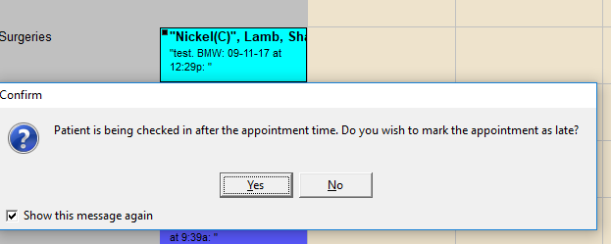
Please select no to this message unless the client is truly late for their appointment.
Please do not unclick this message! It is computer specific and will mark every patient as late.

- Vetsource: There is currently a contest to see who can get the most people on autoshipment (prize to be determined). Here is the information we will need from the client to get them started:
- The diet.
- The size of the bag.
- The card number (including the exp. date and and 3-digit security code)
- How often they want the food autoshipped.

- The number on the top of the line item will tell you how much of a medication we have on hand in the hospital.
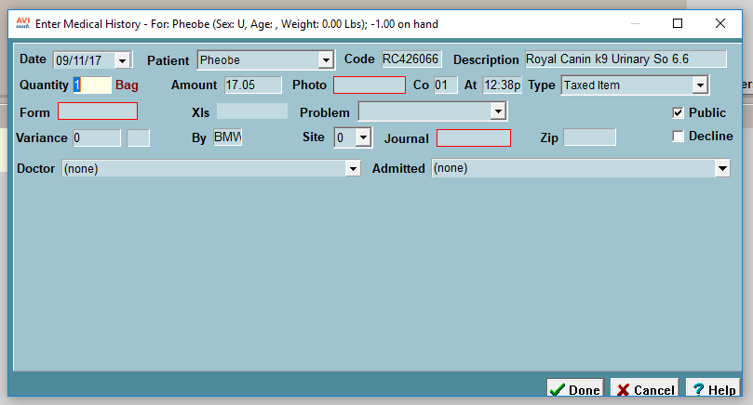
This tells us that there is one bag of this Royal Canin diet in stock.

