12.13.17
Group Meeting Notes

Shannon:
- Vetsource: Now shows your promo discount before checking out! Remember is 15% off PLUS $8.00 off your first bag (Hills Diet’s only) If you see a Chewy prescription request come through, please check to see if Vetsource is cheaper. After processing the order through Vetsource, add the line item “Vetsource Food Order” in Avimark and add how long it’s approved for (typically 1yr). This line item will show up in the diet tab of the patient’s record. 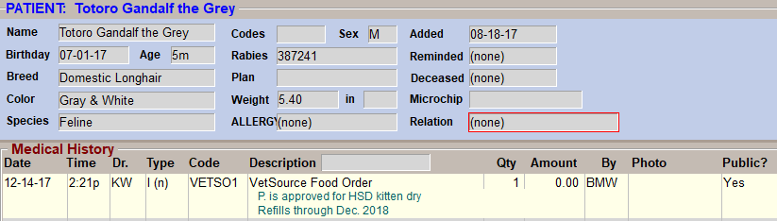
- Feliscratch: New product by Feliway. Apply to a new scratching post, not the couch – IT IS NOT A REPELLANT! We sell it by the bag ($32.10) and will be kept on the shelf in reception. Make sure to let the clients know it is a blue dye that will stain (used to be visually appealing to the cats). Clients may need to redose in the future based on stressors (new housemate, moving, etc) but one bag should be used to solve the issue. Brochures are located in the bottom drawer under the Hills brochure rack in the treatment area.
- Health Certificate Flow Chart: Dr. Gawel made a flow chart to help everyone when we get a request for a health certificate. Keep in mind that we need 3-day window for international health certificates to be sent to NY for the USDA vet to sign it. The flow chart will be kept in the Drs. Office, in reception, and in the magazine rack of the treatment area.
- Re-shelving Medications: Make sure to check the bottle and the actual pills when filling a medication and before re-shelving!
    - Revolution: Please keep in foil packets when breaking down a box for single doses.
    - Frontline: Please sell the singles doses that are in their own package (not a broken down 6-pack)
  - Faxed Prescriptions: Please use the “faxed prescriptions” line item instead of a Dr Note, CCOM, or Tech Note. There’s currently a $10.50 charge for the line item, please ask a Dr to change the price.
  - Drop-Off’s: Write down the best number to reach the owner FOR THE DAY don’t assume it’s the primary number we have on file. Also make sure to go over the questionnaire before they drop off.

  - Dr. Haase Surgeries: Please schedule these in the “scheduled block-off” section in the surgery column. This allows the surgery doctor not to limited on the number of surgeries we schedule.

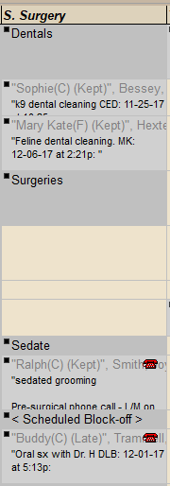
  - Boarding: Make sure to label the Sunday pick-ups and send the owner home with the sheet that discusses our Sunday pick-up protocol.
      - between 6-6:30pm on Sundays. Client calls the tech phone to inform kennel staff that they have arrived.
      - There are no drop off boarders on Sundays, only pick ups.
      - Clients should pre-pay for Sunday pick up or have a credit card stored to be ran on Monday.
  - Ultrasounds: If the owner wants to stay for the ultrasound, schedule it in the Work-In column in the correct time slot. Also note what time Dr. Haase plans to be here. Drop off ultrasounds should remain in the drop off column in the correct time slot. If the owner is undecided, keep the appointment in the drop off column and make a note that the owner is undecided.
  - Room Organization: Techs will restock all of the exam rooms at the end of the day as part of their daily duties. Dry erase checkoff list coming soon for each room.
  - FNA & UA list: Still need people to sign off! Please feel free to practice on leftover urine for the UA’s and fruit for the FNA’s.
  - Controlled Drugs: Controlled drugs should be locked back in the cabinet during surgery as soon as possible.
  - Laser Treatments: Remember to hang the signs on both doors of the room you’re using, use the goggles and log the treatment in the log book!
  - Heartworm Prevention: There is a 2-month rule on missed heartworm prevention. ALWAYS recommend sending home a year supply when refilling heartworm prevention.
  - Tablets: Remember to give these to clients when there’s a long wait time. They are kept in the office on Dr. Tabony/Dr. Gawel’s desk.
  - When an owner declines a vaccine remember to mark is as declined and suspend the reminders for 65 days. You can suspend them long term if it’s appropriate (ex: suspending FELV vax for an indoor only cat).
Dr. Tabony:
  - Radiographs: We dropped the additional region discount. Now it’s just:
    - Single (pregnancy or stones) *Please make adjustment in Avimark line item*
    - Standard 2-3 view.
    - Additional Cavity (up to 3V)
    - Orthopedic: They are in their OWN category and should always be charged that way.
  - Sedated Grooming: One code now!
    - Feline Sedated Grooming: $62.50. We will no longer add anesthetic recovery on to this fee!
    - Canine Brief Sedation <10 minutes: It would be most correct to change this wording to “Canine Brief Sedation – Grooming” after you have entered it.
  - Hospitalization: 2 levels now!
    - Level 1: NO tubes or intensive care, medications 2-3 times daily (oral or injectable)
    - Level 2: Any tubes (IV, urinary) or force feeding/time intensive care w/o tubes.

2 times to go by…
    - <4 hours:
      - (could be the start or the end of the day). Home by 11:30am if stayed overnight to qualify.
      - 1 hour forgiveness: If a pet arrives in the last hour or goes home in the 1st hour of the day, there are no hospitalization charges for that transition time (but in the case of the morning example, there would still be a Dr. exam, meds, etc.)
    - >4 hours: This is per calendar day, not combined from one day to the next.
      - Level 1: Nursing care, ICU occupancy.
      - Level 2: Nursing care, ICU occupancy, daily progress exam. *Call-in exam on the weekend or holiday is an additional fee “Hosp. Case Dr. Exam – On Call” $75.00
***Does NOT include***
- Overnight board (add Hospitalization: ICU overnight)
- Isolation fee - $30/day for hospitalized patient.
- Fluids
- Food (prx)
- Medications

***Pricing***
    - Hospitalization Level 1 <4 hours - $35.00
    - Hospitalization Level 1 >4 hours - $55.00
    - Hospitalization Level 2 <4 hours - $75.00
    - Hospitalization Level 2 >4 hours - $130.00
    - Hospitalization ICU Overnight - $25.00
- Exams:
  - No change to the standard exam price - $45.50
  - Progress exam - $36.50 (20% off regular exam price)
  - Urgent care exam - $65.50 ($20 more than our regular exam price)
- Outpatient Sedation: Typically Dexdomitor and box-downs.
  - Feline:
    - Brief Sedation (up to 10 mins.) - $75.00 CODE: FELSED1
      - Includes: Sedated exams, Nail trims (make sure to charge), and blood draws (not procedures)
    - Extended Sedation (11-20 mins.) - $120.00 CODE: FELSED2
      - This allows the Dr. to choose the protocol that’s best and include oxygen and handheld monitor.
    - Sedated Grooming - $62.50 (about $18 higher than before, Kelly will alert clients to the increased fees as she sees them on her schedule.)
      - Includes: Sedation meds, monitor, patient recovery, hospitalization associated with the procedure.
      - DOES NOT Include: Wound care, procedures, supplies.

  - Canine:
    - Brief Sedation (up to 10 mins.) - $95.00 CODE: CANSED1
      - Includes: Dexdomitor (IV or IM but IV preferred where possible). Also includes Torb, Antisedan, Oxygen and handheld monitor.
    - Standard Sedation (11-20 mins.) - $150.00 CODE: CANSED2
      - Includes: Dexdomitor, Torb, Antisedan (used or not) Oxygen, handheld monitor. Telazol and iso would be additional if used.
    - Extended Sedation (21-40 mins.) - $190.00 CODE: CANSED3
      - We don’t anticipate this will be used much, but we wanted to have the option available. Includes the same items as above. Telazol and iso are still additional.
    - Canine Radiograph Sedation - $65.00
      - The expectation is that we will be using ½ dose Dexdomitor and ½ dose Antisedan (or another inexpensive combo like Ace/Torb). If we will use full doses, then Canine Brief Sedation is most appropriate.
      - Includes: Sedation meds, monitoring, recovery and hospitalization associated with the procedure.
      - DOES NOT Include: Wound care and procedures/supplies.

- Surgery:
    - CRI pain control – Increased to $48.45
    - Surgery sedation cath/fluids increasing after the New Year (but not yet)
    - Iso fee/min – Increased slightly to $3.70/min. (this will now only be used after 30 mins.)
    - Anesthesia: Now 1st 30 mins - $258.00
      - Includes: Premeds, induction, monitoring, iso/min up to 30mins.
      - DOES NOT Include: NSAID (still under “perioperative pain control”) Surgery supplies/time, recovery, iso/min after 30 mins. (this will need to be added as additional time)
    - Coding simplification: Use “SX1” which gets you about 10 surgery codes so you don’t have to remember them all!
- Fluids:
  - IV Fluids bundle: price is $120.00
    - Includes: IV pump, IV cath., IV line/T-set, 1st bag of fluids
  - Additional bags are rising in cost and MUST BE CHARGED! If you change a bag, YOU enter the charge. (CODE: FLUIDADD)
  - Additional IV fluids (per bag) are $31.25. An inventory item is linked, please choose which type of fluids you’re using.

