11.21.17
Group Meeting

Dr. Cain: Animal Chiropractic
- $55 per adjustment (no consultation required)
- 2-week follow-up session; then longer based on 2nd visit.
- There are no audible sounds heard during adjustment like in people.
- Adjustments are available for dogs, cats and horses.
- Chiropractic adjustments allow the body to function at it’s fullest compacity.
- There is no age limit or requirement.
- Dr. Cain’s email: drcain@carolinavetrec.com
Shannon:
- The technician manual is done! There are printed copies in the treatment area and in the break room. It is also on the server and has been emailed to all technicians. Everyone should have it read within the next TWO WEEKS! You can receive 5 raffle tickets if it’s read within a week (deadline: 11.28.17) and another 5 tickets if you take a quiz.
- New reminder cards! Our new reminder cards will now include the pets picture on them, if there is no picture in Avimark, they will add a stock photo according to the pet’s breed. RECEPTION: Be prepared for owners to call in saying the picture isn’t of their pet. Please let them know they can email us a photo to upload for them or tell them we will update their picture the next time they’re in the office.
- Reminder: please do not post things that didn’t happen or didn’t leave the building.
- Please do not leave “Return to Stock” (RTS) stickers on returned items (especially food) we do not need to display another client’s information to other people.
- “Easy Work-In” slots are now called “24 Hour Appointments” Email clarification coming soon. If you schedule in one of these slots, please make notes in the appointment screen. Ex – “Owner couldn’t come in at the 4pm open appointment due to work schedule.”
- Please call all numbers listed in Avimark when trying to get in touch with an owner & add date/time stamp when making client communication notes.
- Please get accurate information when clients are checking in (address, phone numbers, email, etc)
- When checking in a drop off, please get the best phone number FOR THAT DAY. (Ex. If the owner is going to work, we shouldn’t be calling their home number)
- Reminder color codes:
RED – Past due
BLUE – Due within the next 3 weeks.
GREEN - Manually changed (NEVER change a Rabies vaccine)
- Please continue to add items that were declined to Avimark, this helps us keep our medical records as accurate as possible.
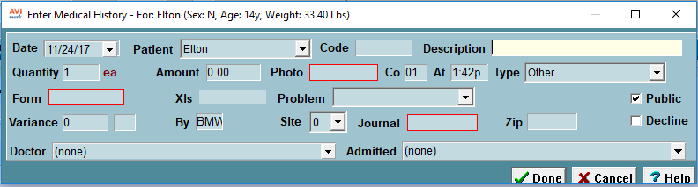
- How to suspend a vaccine reminder:
1 – Double click the vaccine you want to suspend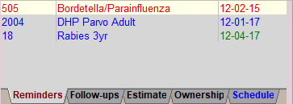
Double click here
2 – Click “Advanced” 2 – Click “Advanced”
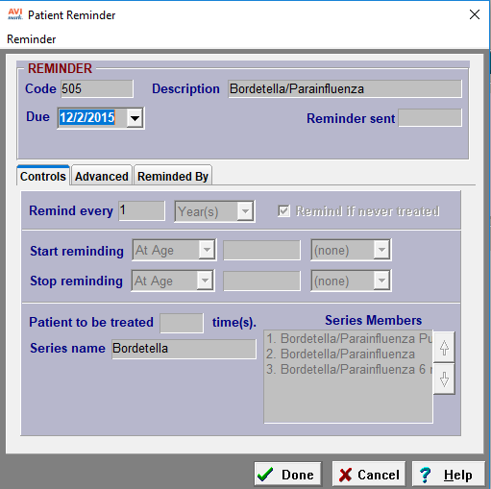
3 – Click “Suspend” **If you send a fecal cup home, please suspend the reminder for 65 days**
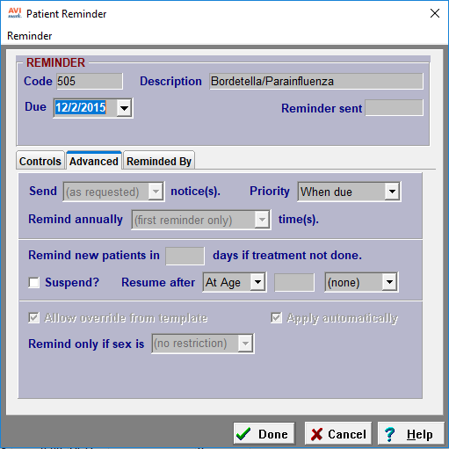
- How to suspend all vaccine reminders:
1 – Right click in the patient area and click change
2 – Hit the code “H”
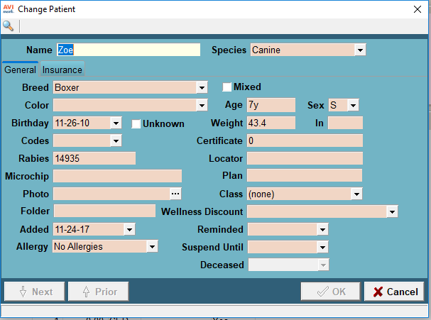
3 – Make a note in the more notes section as to why we are suspending reminders.
Dr. Tabony
- Dr. Tabony is now offering acupuncture for cats and dogs on Tuesday mornings and Sunday evenings.
- Microscope reminders: Always start looking at the slide by focusing on 10X (yellow). If you need to look at it on 100X using oil, go straight to it, DO NOT go to the 40X. (Remember Maddy’s rule: 40X is “high & dry”) and please clean the microscope when you’re finished!
- There are Trazodone dosing guides located near both exam computers, treatment computer and surgical computer.

