1.24.18
Group Meeting Notes
Shannon:
- Happy Belated B-day Becca
- Service Stars:
- Melinda and Jenna for coming in early on Thursday after snow
- Libby for getting the drop off bath done so quickly on 1.24.18
- Everyone who has taken extra shifts or rearranged your schedule to cover the gaps
- Dental Health Month Special:
- $10 dental radiographs for the month of February (carried into March if for scheduling purposes). Enter radiograph charge like normal but add code 2590 “Dental Health Month X-Ray Discount”
- $25 off dental cleanings through the end of March for those who bring in the email or mention the offer. Add charges like normal but add code 25YRS “25th Anniversary Celebration Discount”
**Client may choose ONE of these promotions, not both!**
- Written Script/Faxed Script: Please use the code FAXRX for faxed prescriptions or WRRX for written prescriptions. Ignore the $10.50 charge (it will not charge the client). Please include the product name and mg., quantity, number of refills, who you’re faxing it to, and date/time stamp.
- 24 Hour appointment slots: These slots are meant to be filled! You do not need to ask a doctor to fill them. Only to be filled 24 hours in advance (no further than one day out)
- Forward Booked Confirmation: You should be asking clients at every check out to book their next appointment. Techs should start the conversation in the room or book it while the client is in the room. Appointment book is currently out through Jan 2019 and will be done through June 2019 by next week. If client is hesitant, remind them that they are able to cancel/reschedule at any time and we will send out reminders 1mth in advance.
- Write helpful notes on chart- client waiting in car (blue Toyota Camry)
- Computer Use: NOT FOR PERSONAL USE!! No shopping, paying bills, looking for a new car, etc while you are supposed to be working!
- Appointment notes: We want more info. For annual exams, you should always ask while scheduling, “ Are there any concerns you need Dr ____ to address while you are here?”
- Please use the puppy/kitten visit codes that are red (you will not see the line item in Avimark but it will link several codes together.

- Puppy/Kitten Fecals: Standard of care is two during series
- Reminder will prompt at first visit for 42 days, then after second will remind one year later.
- If positive for Giardia or Coccidia, manually change reminder date to the next visit.
- Declined Fecals- “Since we are not checking for intestinal parasites, we NEED to give him/her a dewormer”
- Reviewing client history
- Toilet paper/Paper Towels- If you use the last of it, change it out!
- Post follow up calls from follow-up tab NOT CCOM
- Always remove Dr Kaylor’s follow-ups.
- Cage cards and Name tags- USE THEM (as soon as the pet arrives)
- Sodium Chloride- On back order. There are several boxes of LRS in the stock room. IF your patient HAS TO HAVE Sodium Chloride, we have a few bags but are trying to reserve those in case they are needed in sx.
- Remove prepaid label instructions if you obtain and send out samples
- Estimates – Osurnia- There is an issue putting Bilateral on an estimate (fee is incorrect). It is best to enter it in the record like you are going to do it and present client with a pre-invoice.
- Quoting prices/linked items- There are several charges that are linked to others.
- Correcting mistakes in Avimark- The record should accurately reflect what happened. Do not enter negative quantities for product just to make the math come out correctly or if you post it accidently. Have someone correct it so that the MEDICAL record is correct!
- Text messages default to Dr Tabony in Avimark, this does not mean she is every patient’s doctor. You need to scroll through the history to see who generally examines the patient.
- Pulling up vaccines before speaking with the client. We waste hundreds of dollars pulling up vaccines that we do not administer. The numbers below show how much (that were documented) over the last couple of years.
- 2016- $401
- 2017- $350
Dr. Gawel – Fear Free Presentation
- Agression - should be thought of as a clinical sign; Underlying causes: Play, Redirection, Resources, Territory and FEAR!

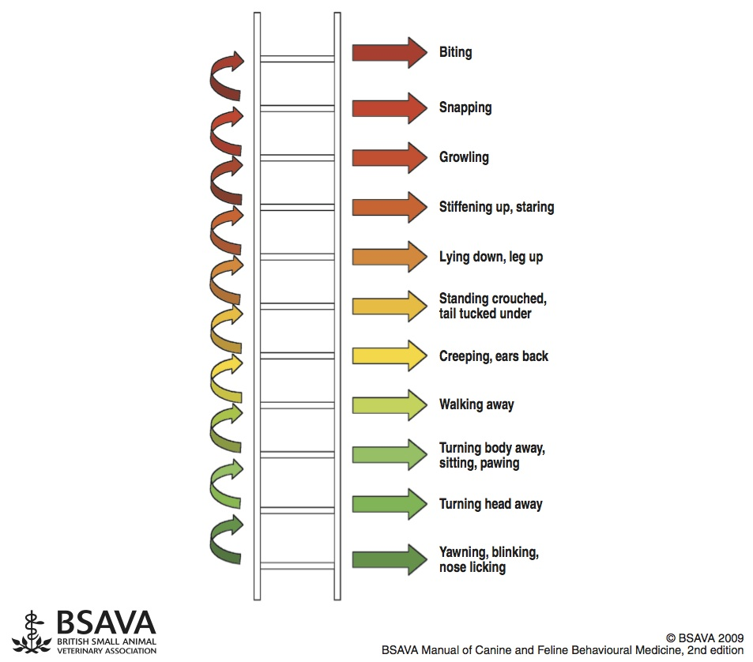

- Reasons why being fear free is important:
- Safer visits/happier patients
- Recognizing signs earlier
- Less tension/stress
- Listen to the patient!
- Ways to help the patient:
- Stop what we’re doing / limit eye contact
- Allow acclimation (i.e., sniff palms, allow to come to you)
- Offer treats
- Pre-Visit Pharmaceutical (Trazodone, Gabapentin)?
- Move to a different area.
- Implement personal protection if needed – muzzle, towel scarf, basket muzzle
*Our owner should not be holding *
- Take a moment to observe our patients when you enter the room
- Don’t be afraid to STOP, reassess, and suggest pre-visit pharmaceutical / alternative techniques
- Let’s avoid hearing – “that dog bit me out of nowhere!”

